The **JavaServer Pages Standard Tag Library** (**JSTL**) is a component of the [Java EE](https://en.wikipedia.org/wiki/Java_EE) [Web application](https://en.wikipedia.org/wiki/Web_application) development platform. It extends the [JSP](https://en.wikipedia.org/wiki/JavaServer_Pages) specification by adding a [tag library](https://en.wikipedia.org/wiki/Tag_library) of JSP tags for common tasks, such as [XML](https://en.wikipedia.org/wiki/XML) data processing, conditional execution, [database](https://en.wikipedia.org/wiki/Database) access, loops and [internationalization](https://en.wikipedia.org/wiki/Internationalization).

1. Initialization in header

<%@taglib prefix="c" uri="http://java.sun.com/jsp/jstl/core" %>

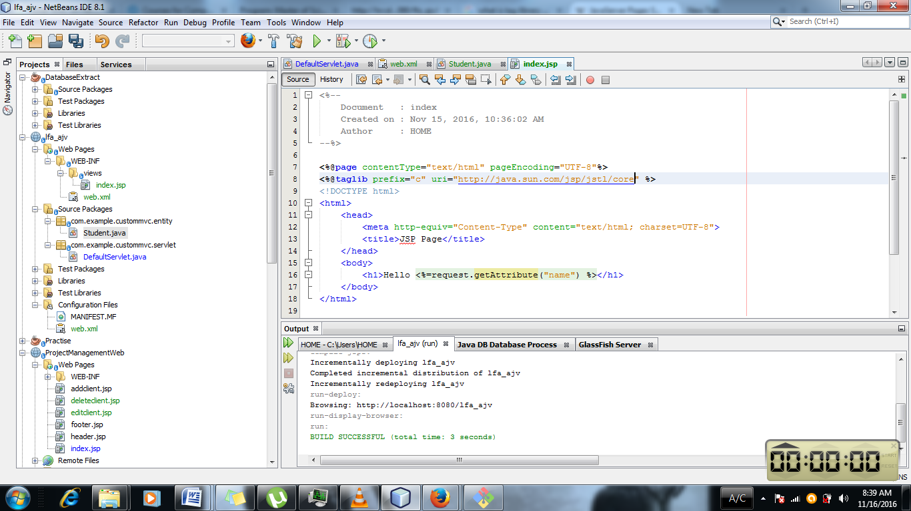

1. Usage of <c:forEach var=”i” begin =”1” end=”10”>

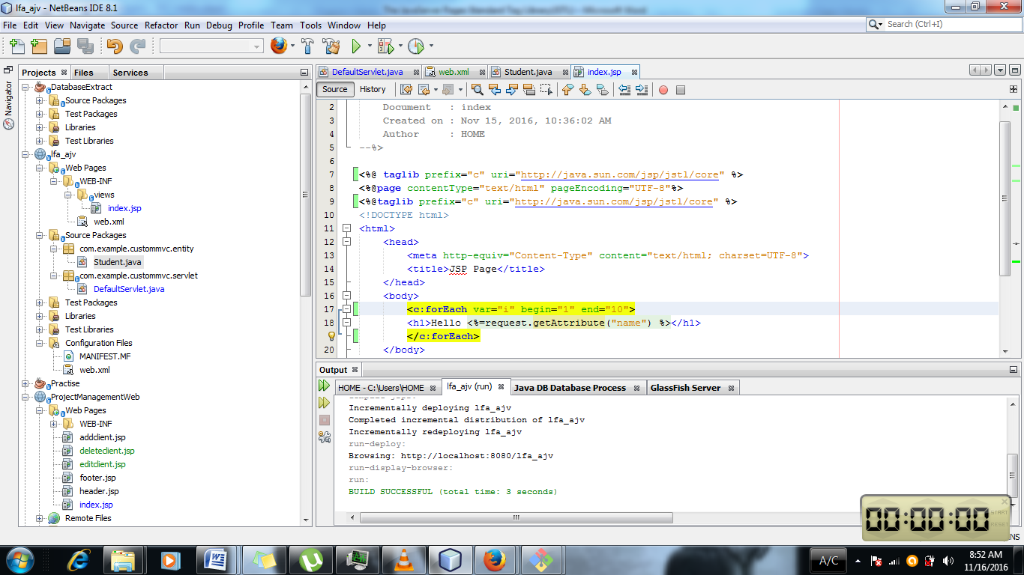

${} is expression language and it can be used for implicit objects instantiated already in java.

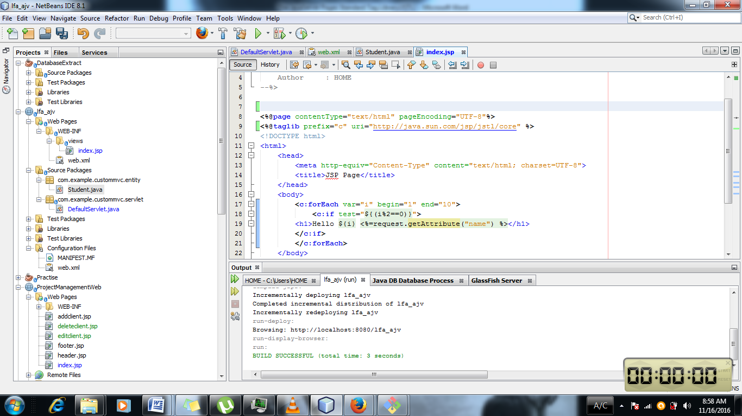

Condition is inside the ${} and the variable test is used for determining the condition.

<%=request.getAttribute("name")%> is same as that ${requestscope.name} . so previous one is java code . As it has to be compiled again and is unsecure that is why expression language is used.

JSP Expression Language (EL) makes it possible to easily access application data stored in JavaBeans components. JSP EL allows you to create expressions both **(a)** arithmetic and **(b)** logical. Within a JSP EL expression, you can use integers, floating point numbers, strings, the built-in constants true and false for boolean values, and null.

There can be 1000 servlets so instantiating the servlet and servlet mapping in web.xml will not be practical .

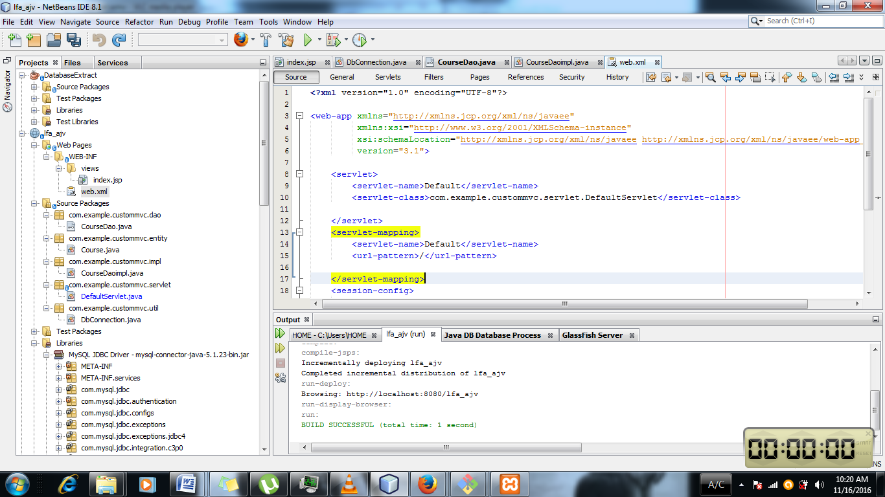

So instead the WebServlet is defined in the default servlet classes. So

@WebServlet(name = "default" , urlPatterns = {"/","/home"} ) is used on the Default Servlet class where it is needed.

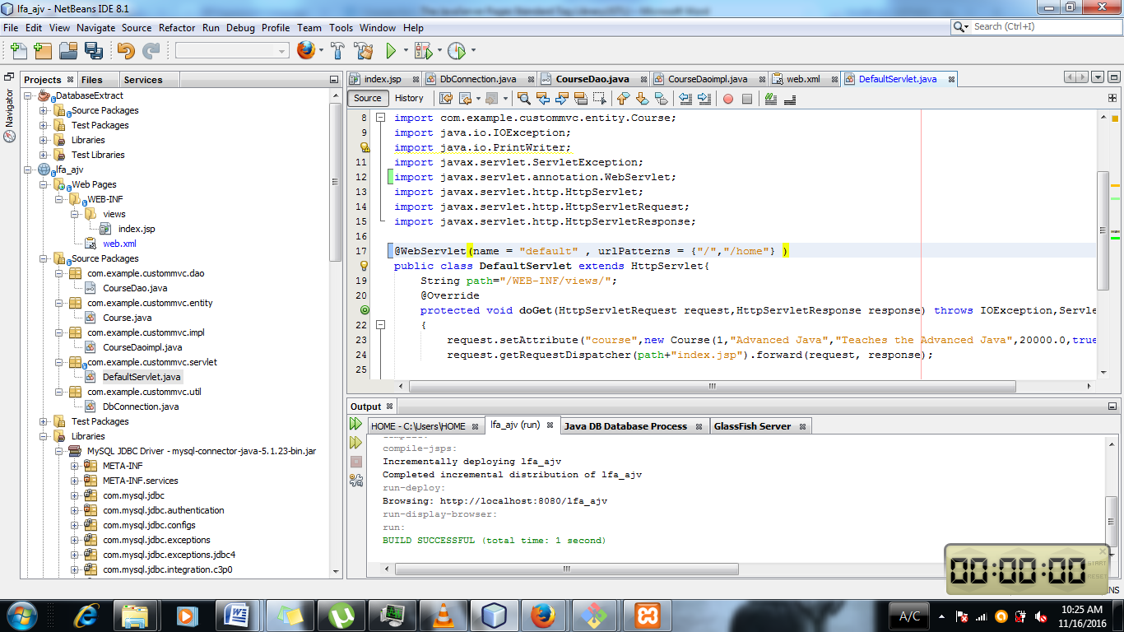

1. Connection to the coursedao

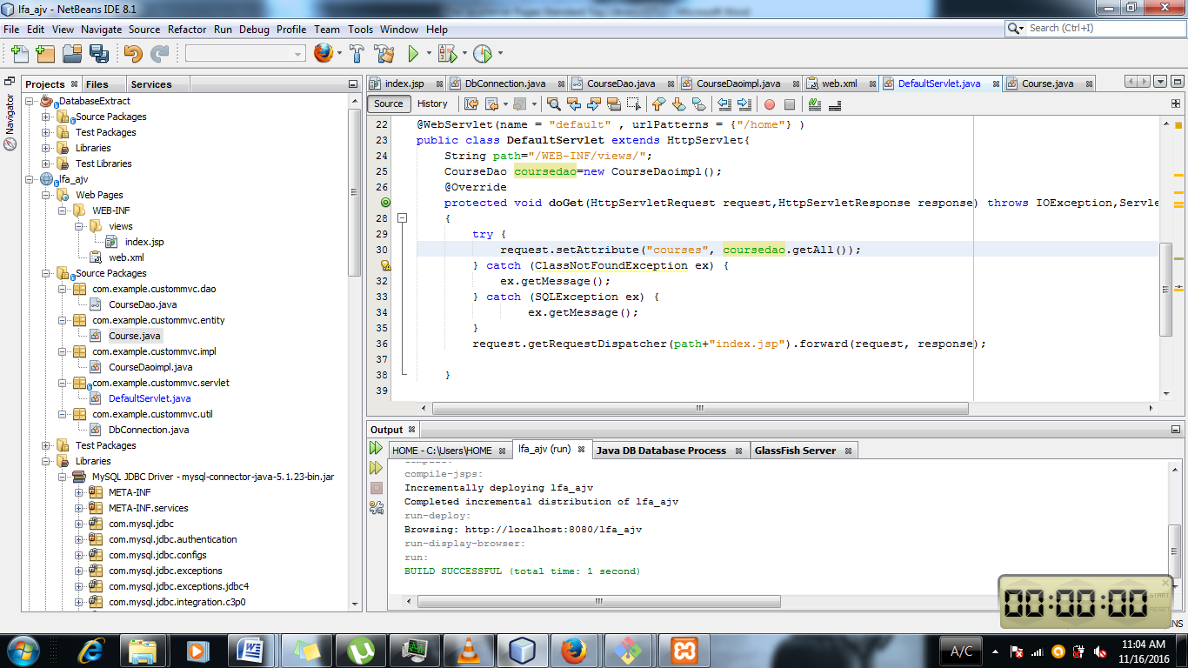

1. Implemetation in the jsp without using java code . Instead the regular expression is used.

